e-shopping-app

backend 🡪 spring boot with micro service

frontend 🡪 angular application

type of user or actors : admin, customer etc.

admin : SignIn no SignUp for admin (only one user )

emailid : [admin@gmail.com](mailto:admin@gmail.com)

password : admin@123

admin dashboard

product -🡪 Add Product, view Product, Delete Product and update product information

view all order details.

this information we can store in db or while running spring boot we can create admin account.

Customer : SignIn as well as SignUp functionality

Customer dashboard

Product 🡪 View all product

Orders 🡪Customer can place the order for one product or many products through cart.

View only its own order details.

Created folder with name as capstone-projects;

Then inside this created folder frontend(angular) and backend(spring-boot)

<https://start.spring.io/>

Backend folder

1. Eureka Server

Starter 🡪 Web Starter

Starter 🡪Eureka Starter

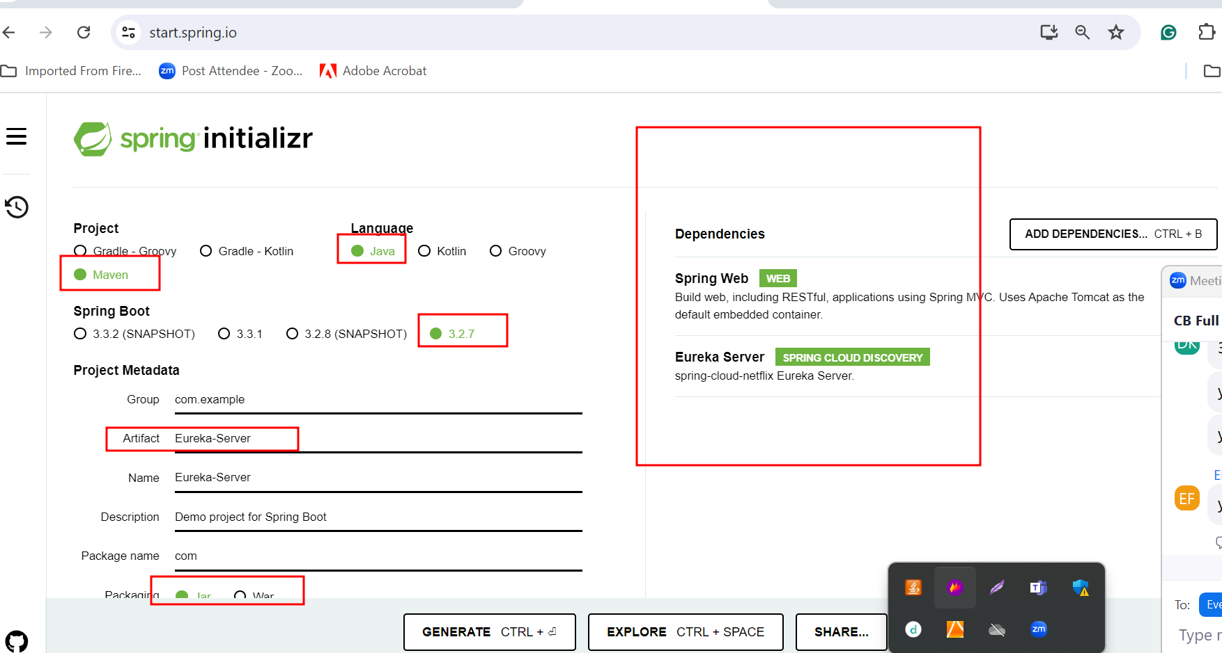

2nd project : login-app-micro-service

Starter -🡪 Web Starter

Starter 🡪Jpa Starter

Dependency 🡪MySQL

Starter 🡪 devtools

Starter 🡪Eureka Client

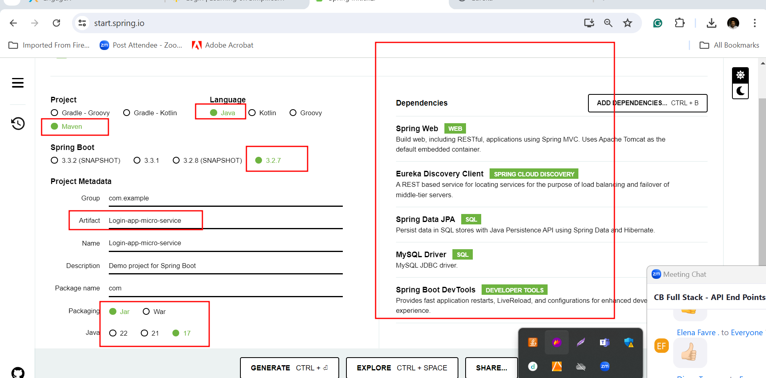

First check version of ng

Then uninstall the your machine ng using below command

npm uninstall -g @angular/cli

Then install

npm install -g @angular/cli@16.0.1

ng version